**Edge AI-Powered Home Health Monitoring System"**

# **UPPALA SAI ASHISH 1 VUTLA YESHWANTH KUMAR 2 NAREDLA SHIVAMANI3**

# **TIRUMALA ANIL4 CHINNA RAJU5**

1Student, Department of CSE(AI&ML), CMRCET, Hyderabad, Telangana, India

2Student, Department of CSE(AI&ML), CMRCET, Hyderabad, Telangana, India

3Student, Department of CSE(AI&ML), CMRCET, Hyderabad, Telangana, India

4Student, Department of CSE(AI&ML), CMRCET, Hyderabad, Telangana, India

5Assistant Professor, Department of CSE(AI&ML), CMR College, Hyderabad, Telangana, India

**EMAIL:** [saiashish4545@gmail.com](mailto:saiashish4545@gmail.com2)1

# **ABSTRACT**

When there are pandemics and epidemics, healthcare systems are put through a lot of stress. One disease that quickly spreads from an infected individual to others is COVID-19. Offering noncritical patients isolation through home-based healthcare services can help ease this strain. Additionally, this method is very helpful for keeping an eye on the health of elderly people who live at home. health monitoring is one method for continuously monitoring a patient who are suffering with health problems or elderly person that uses non-intrusive visual sensors. This article describes a home health monitoring edge computing strategy based on transfer learning. Using a limited amount of labelled data and fine-tuning methods, a pre-trained convolutional neural network (CNN) model can be adapted for edge devices. This makes it possible to process data that is captured by RGB, thermal, or depth sensors on-site at a low cost. Raw sensor data no longer needs to be sent making it safer and more private.

Keywords— Health Monitoring , Artificial Intelligence , Cv, COVID 19, DL, Edge ,Sensors.

I. INTRODUCTION

The IOT and the rapid development of AI have revolutionized healthcare by providing personalized treatment and instantaneous home-based health checking has emerged as a useful strategy for managing chronic illnesses providing care for the elderly and recovering from surgery. However problems like network congestion, high response time and concern over privacy are common for conventional cloud based solutions. Edge computing which processes information closer to the source from where the information is being received and reduces delays while improving data security offers a viable alternative the accuracy and usefulness of home health monitoring. Systems are enhanced by the advanced ai technique known as deep transfer learning and this makes use of pre trained deep learning techniques for brand new models that are using deep transfer learning methods on edge devices and allows these models to be fine-tuned using finite information and resources making ai-powered health monitoring feasible on devices with restricted processing power this approach enables precise and rapid detection of health anomalies activity recognition and early disease identification the lc25000 dataset is used to evaluate the models performance which produced detection rates of 9905 percent for lung cancer and 100 percent for colon cancer by involving transfer learning edge computing home health monitoring can overcome key challenges like real-time processing less reliance on cloud infrastructure and increased patient privacy using edge computing devices like mobile phones wearables and sensors these systems can analyze vital signs movement patterns and other health parameters without sending a lot of data to central servers.

II. **LITERATURE REVIEW**

***“Covid in India : State by state  prediction of present hospital services and ICU beds”***

*The global spread of covid has prompted policymakers to reevaluate the limitations of health care facilities numerous severely affected areas and localities have experienced major problems with dangerous cases brought on by existing hospitals it is essential to consider a nations capacity to treat dangerous cases as covid spreads in India.*

1. ***Hospital readiness for covid pandemic***

*The health care sector readiness for the covid pandemic because they are able to provide medical assistance to the community especially during prolonged outbreaks hospitals play a crucial role in the health system however it can also be able to aid in the spread of the disease as a result of rising service demands which may overburden hospitals capacity to provide additional facilities amid pandemic difficulties the generic priority action must be ensured by managers.*

1. ***A nurse-led approach to developing AI in homes .***

*A  nurse-led approach to developing ai in homes to give real-world guidance for nurse researchers with an amuse in various researches including helping to develop ai algorithms for intelligent health management.*

1. ***Homecare robots for health care.***

*Homecare systems for health driven care are manufacturing-based innovations the modern age in medical management inventions is in progress health related services is one example of this revolution new eras homecare computerized systems based on ai are emerging with greater execution speed and intelligence.*

1. ***Remote patient monitoring: a brief study.***

*Healthy lifestyle choices help prevent type 2 diabetes and its complications yet many struggle with self-management this study developed a mobile app that tracks diet health data and activity using bluetooth-enabled insoles machine learning models achieved 86 accuracy in classifying movements with a decision tree model enabling real-time tracking mobile health apps are becoming vital for chronic disease management*

1. **PROBLEM STATEMENT**

During pandemics or widespread various diseases like covid healthcare system faces immense pressure due to the rapid transmission of deadly infections high demand for various medical resources limited availability of hospital beds and further complicates the situation making it challenging to monitor all the infected people especially are suffering with non-critical problems as a result home-based monitoring solutions have become essential in easing the strain on healthcare infrastructure while ensuring continuous patient care.

Old age individuals who live independently are especially at risk requiring continuous monitoring to detect health problems at an early stage old age monitoring methods often involve transmitting raw data to external servers for processing which bought up the numerous doubts about privacy security and bandwidth usage additionally systems may lack real-time prediction capabilities leading to delays in medical intervention therefore there is a growing necessary a secure efficient and fast and real-time health supervising system it can function entirely within a patients home.

A DL based edge computing method approach provides a viable solution to these challenges by leveraging pre-defined or trained cnn models fine-tuned with minimal labeled data devices can analyze visual inputs from various sensors like rgb depth or thermal cameras within the home itself this eliminates the need to send raw data to external servers enhancing both privacy and security furthermore on-site data execution reduces latency allowing for on time health supervising and timely medical responses this method is also cost-effective and optimizes.

1. **MODULE DESCRIPTION**

The proposed DL based Edge Computing approach for Health supervising consists of several essential modules, each designed to facilitate secure and efficient health tracking within a home setting:

1. **Sensor Data Acquisition Module:** This module captures real-time visual data through various sensors, such as RGB cameras, depth sensors, and thermal imaging devices.
2. **Pre-trained Model Deployment and Fine-tuning Module:** A pre-trained (CNN) model, originally supervisied on a large and relevant dataset in a cloud environment, is deployed on an edge device within the home. To personalize the efficient model for the specific environment and individual being monitored, for a minor amount of locally collected, labeled data that used to fine-tune the model directly on-site.
3. **METHODOLOGY**

The tl-ec-hm mechanism combines both the transfer-learning as well as edge-computing on devices itself to enable efficient and real time monitoring of a persons health condition while prioritizing privacy by calculating data in availability devices that are edge instead of depending on cloud system which is time taken processing fast decision making and dependency on external systems or outside system workflow.

**System Workflow**

* **Data collection and preprocessing:**
  + The thermal and rgb sensors collect visual inputs in order to track health-related activities..
  + Preprocessing methods like normalization and noise reduction are added to data to make it more accurate and reliable.
* **Model Selection and Training:**
  + A pre-trained deep learning model is adapted through transfer learning and allowing it to perform health monitoring tasks with minimal training data.
  + When evaluating the model's performance, very useful tasks like accuracy, precision, and f1 score are utilized to guarantee the model's efficiency..
* **Real-Time Processing on Edge Devices:**
  + The optimized model runs locally on edge devices, enabling on-site health data analysis.
  + This approach minimizes latency reduces bandwidth usage and enhances privacy by keeping sensitive data within the home .
* **Health Anomaly Detection:**
  + The system identifies abnormalities like falls unusual movements or other health-related concerns .
  + When potential risks are detected quick alerts are sent for correct intervention and increased patients safety.
* **System Implementation:**
  + Python was used to implement the solution which features a user and caregiver-friendly interactive interface.

**FLOWCHART**

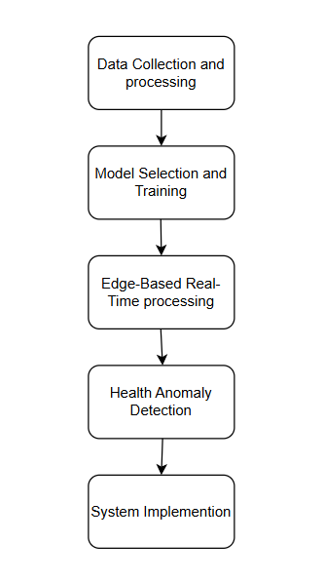

**BENEFITS**

1. **Low connectivity speed power utilization:** This system checks health data solely in edge computing devices keeping private data private from within the home safe and reducing unknown data which are associated with the storage via cloud therefore restricting data breaches.
2. **Instant Health Checking:** With real time checking the system quickly detects falls and other health problems which help in giving quick alerts to their respective family immediate services which is very important for patient safety.
3. **Enhanced Security and Privacy:** The system runs the data completely on the devices comprising edge-computing therefore keeping all the private details restricted to the home itself and minimizing endanger that is associated with cloud storage.
4. **Reduces stress on medical field:** home-based monitoring helps reduce visiting dispensary unnecessarily and lowering the stress on medical field so taking care of patient done remotely available and is made more accessible even during health crisis.
5. **Efficient and Accurate Performance:** By using transfer learning, the model achieves high precision and recall with a minimal dataset, ensuring reliable results while reducing the usage for extensive computing power.

**VI. RESULT**

The performance for implemented methodology like dl based method for health supervising at our very own home tl-ec-hm is evaluates using key metrics such as accuracy precision f1-score results validate the perfomance of using edge computing for on health conditions and their accuracy on-site and it processing the model demonstrates high accuracy in detecting falls and other health-related activities while preserving data privacy.

**A**. **Performance Metrics**

* The TL-EC-HM model gains the high precised accuracy in detecting falls, with an overall precision and recall above 98%.
* This transfer approach enables efficient model adaptation with minimal data reducing computation time while holding high performance.
* This computing ensures low latency allowing for on time checking without need for cloud platforms

**B. Comparative Analysis**

* The transfer learning-based approach immediately reduces the computation needs compared to conventional dl models and edge framework it minimizes bandwidth making the system high speed and high processing proposed method outperforms cloud-dependent health monitoring systems.

By coming to privacy security and system is successfully tested enables users to monitor health from home receive accurate alerts and ensure timely medical intervention demonstrating its practical effectiveness in above image also ai predicted as fall and now test other images in above screen patient condition predicted as no fall and similarly you can upload and test other images.

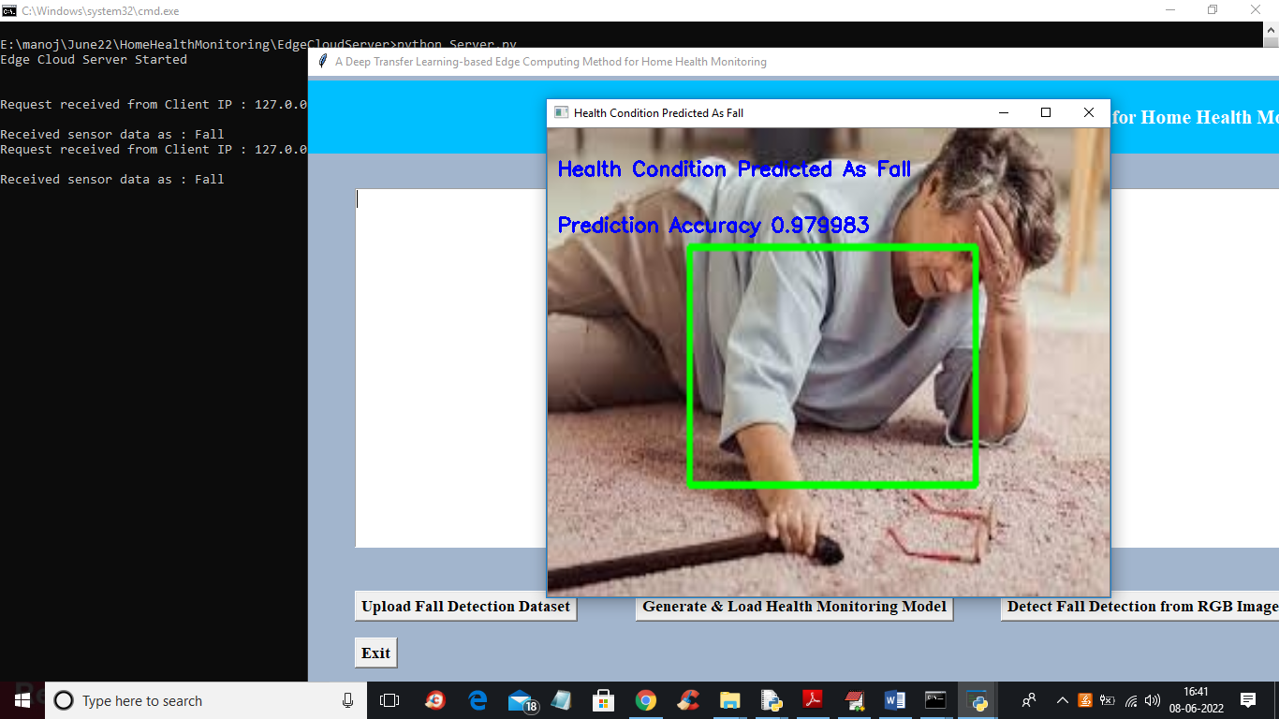

In above image also AI predicted as FALL and now test other images

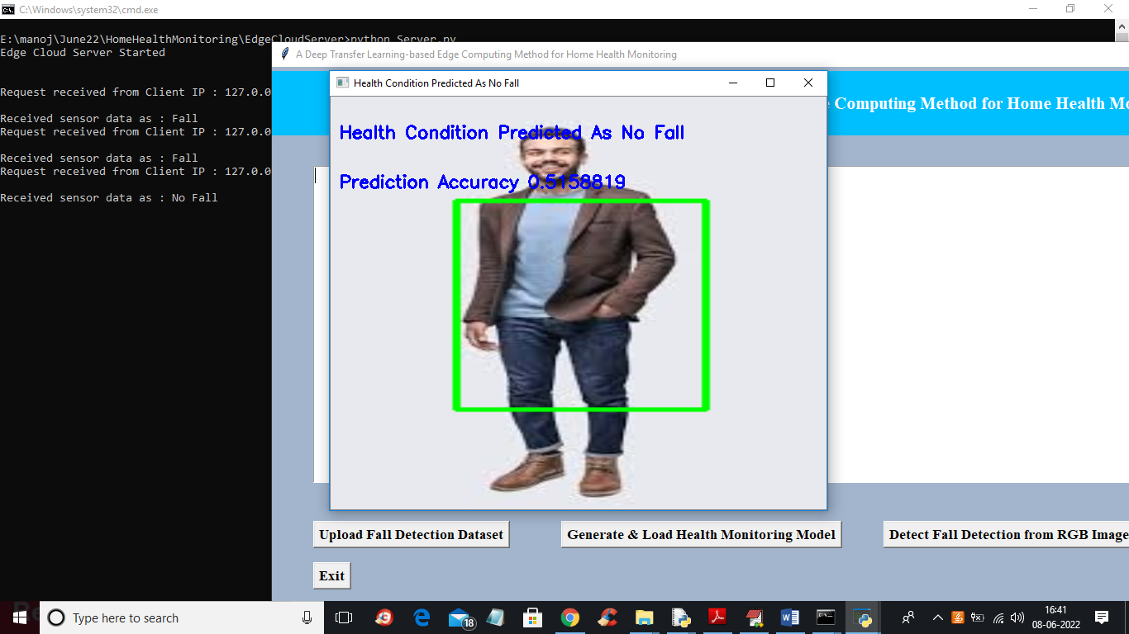

In above screen patient condition predicted as NO FALL and similarly you can upload and test other images.

***VII*. CONCLUSION**

To make less severe for various health related problems in a pandemic or to prevently take care the elders in an a less cost way health health monitoring in home would be highly benefitable method in this we have implemented a cv method that based on a method that is where a dl is used in a popular and highly efficient method called edge computing as computing approach the raw data that continuously and it also rapidly captures with the help of sensors that visualises and it is not requires of home so privacy of data as well as highly secured are it is not a major concerns.